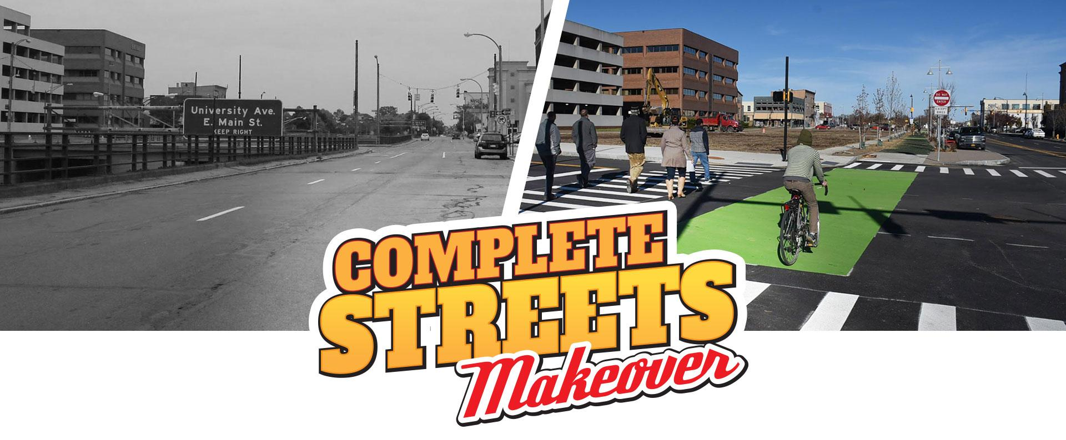
Nomination Form
Is there an intersection or block in the City of Rochester or Monroe County that makes you feel uneasy during your daily travels? Nominate it for a Complete Streets Makeover!
* Required
Location of intersection or trouble-spot *
Please include street names or address and name of city or town.

________________________________________________________________________________________

Why does this intersection or area need improvement? *
A complete street is one that is designed and operated to allow everyone -- regardless of age, ability or mode of transportation -- safer access on that street. Explain why this is not the case.

_________________________________________________________________________________________
_________________________________________________________________________________________
_________________________________________________________________________________________
_________________________________________________________________________________________
_________________________________________________________________________________________
_________________________________________________________________________________________

Your name *
We will need to contact you if we have questions about your nomination or if it is chosen as a finalist.

________________________________________________________________________________________

Email address or phone number *
We will need to contact you if we have questions about your nomination or if it is chosen as a finalist.

________________________________________________________________________________________

What are your ideas for a potential solution?
This is not required, but will help us better understand options and potential for improvement.

_________________________________________________________________________________________
_________________________________________________________________________________________
_________________________________________________________________________________________
_________________________________________________________________________________________
_________________________________________________________________________________________

Explain community/neighborhood support for making improvements to this intersection or trouble-spot
This is not required, but nominations that have community support are more likely to be selected.

_________________________________________________________________________________________
_________________________________________________________________________________________
_________________________________________________________________________________________
_________________________________________________________________________________________

Submit photos or a video of your nominated intersection, street or trouble-spot (optional)
To make your nomination stronger, attach photo(s) with this submission or upload photos and/or video online to http://reconnectrochester.org/dropbox (please include the location where the images were taken in your file name)
___ Yes, I have photos or video to submit.
___ No, I do not have a photo or video to submit.

PLEASE MAIL THIS COMPLETED FORM AND ANY PHOTOS TO:
Mary Staropoli
ATT: Complete Streets Makeover
Reconnect Rochester
Hungerford Complex
1115 East Main St., Box #61
Rochester, NY 14609

